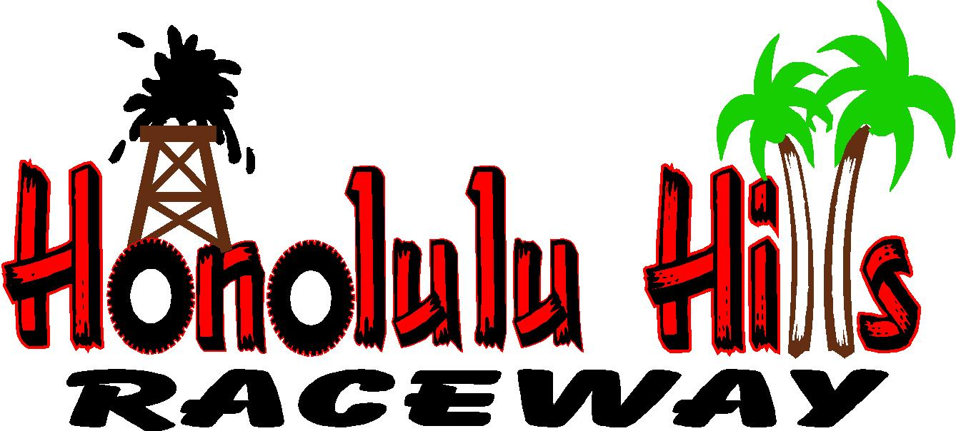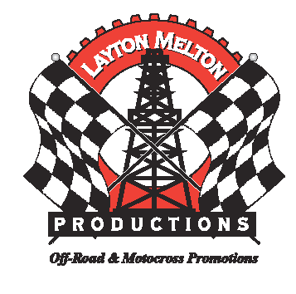

Sponsorships Packages for 2007:

Please take time and review our sponsorship requests for the 2007 season. We are currently seeking sponsors for our Annual Summer & Fall Series.

Sponsorship is an excellent way to get involved in community support. Help support and sponsor your local riders. Spectator passes can be used to hand out to customers or the riders' families. Sponsoring is an excellent business advertisement at the track, on the web, in the newspapers and signage at the track.

The Summer Series will bring in over 1400 rider entries and 10,000 spectators over 6 rounds while the AX/MX Fall series will do equivalent with the newly opened Honolulu Hills Raceway.

Franklin Field currently hosts the annual Summer Series along with special events throughout the year, while Honolulu Hills Raceway will host the AX/MX Fall Series, Round #1 of the Annual Big 6 Grand Prix, The National WORCS Bike & Quad Rounds, Glen Helens ITP Quadcross Round, the Annual ARHMA stop & many more. The Big 6 Grand Prix, WORCS Racing, ARMHA & the ITP Quadcross will bring in well over 5,000 total rider entries and more than 25,000 spectators for the year.

Thank you for your time and consideration in becoming a sponsor for 2007. I look forward to speaking with you and will be happy to answer any questions that you may have.

Any questions, please feel free to call or email me.

Sincerely,

Jason Reed
Taft Racing
(661) 577-6955
jason@worcsracing.com
jasonworcs@bak.rr.com

