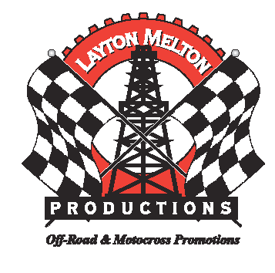
Layton Melton Productions 2007 Sponsorship Packages

AX/MX 2nd Annual Fall Series Packages
$2000.00- 2nd Annual AX/MX Fall Series Package
- (20) Rider Comp Passes
- (30) Spectator Passes
- Logo on Overall Plaques and Trophies
- Logo on flyers, newspaper adds & Banner inside Arena

$1000.00- 2nd Annual AX/MX Fall Series Package
- (10) Rider Comp Passes
- (15) Spectator Passes
- Logo on Overall Plaques and Trophies
- Logo on flyers, newspaper adds & Banner inside Arena

$ 500.00- 2nd Annual AX/MX Fall Series Package
- (6) Rider Comp Passes
- (10) Spectator Passes
- Logo on Overall Plaques and Trophies
- Logo on flyers, newspaper adds.

$ 250.00- 2nd Annual AX/MX Fall Series Package
- (4) Rider Comp Passes
- (8) Spectator Passes
- Logo on Overall Plaques and Trophies
- Logo on flyers, newspaper adds.

